**EXPERIMENT-8**

**USE GOOGLE AND WHOIS FOR RECONNAISASANCE**

**AIM:**

To find out the Whois, DNS Records and Diagonstics for particular website by using Whois search.

**PROCEDURE:**

* Open the WHO.is website.
* Enter the website name in search bar and hit the “Enter button”.
* Show your information about [www.saveetha.com](http://www.saveetha.com/).

**OUTPUT:**

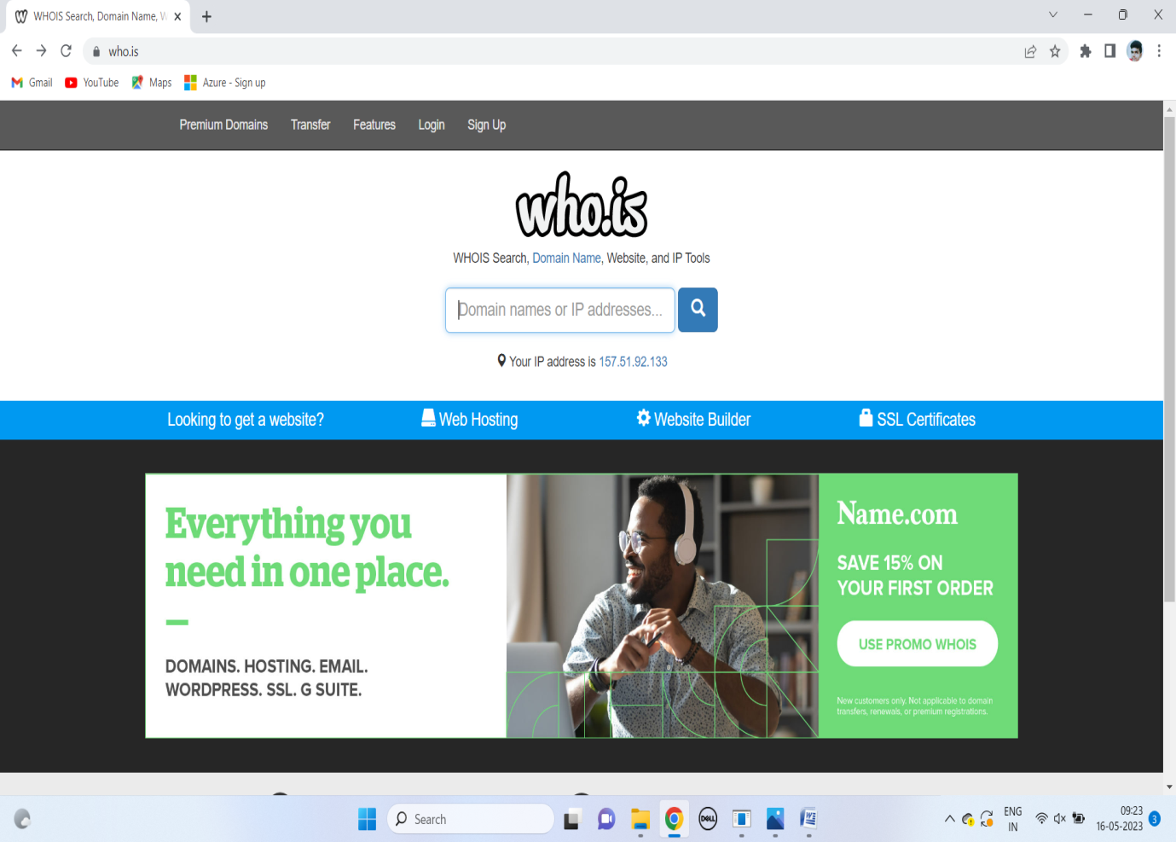

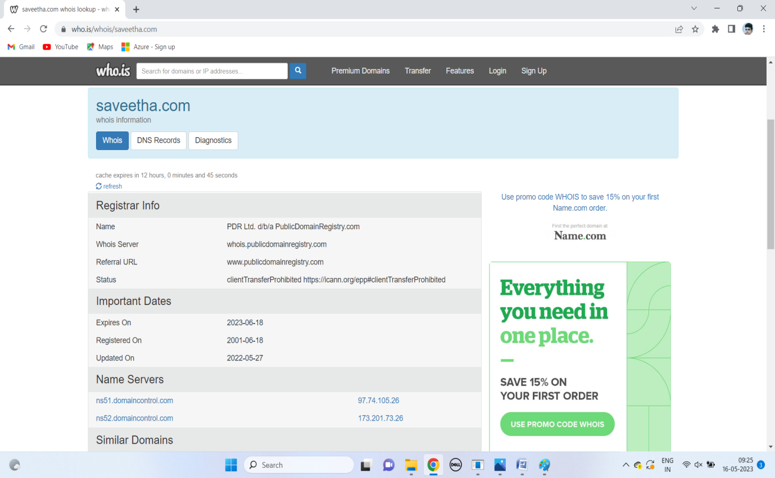

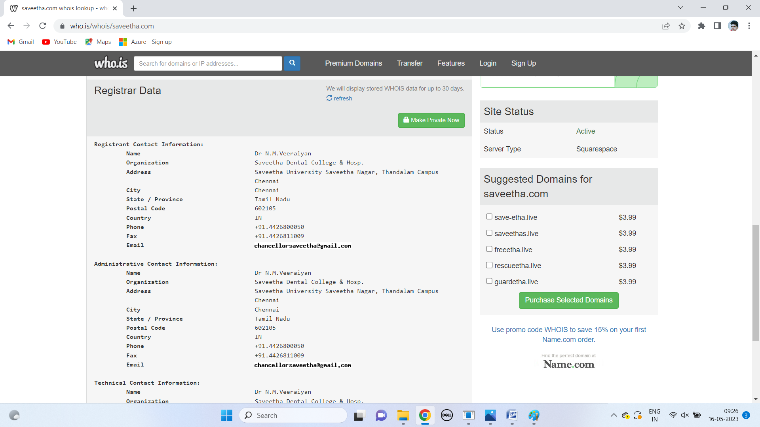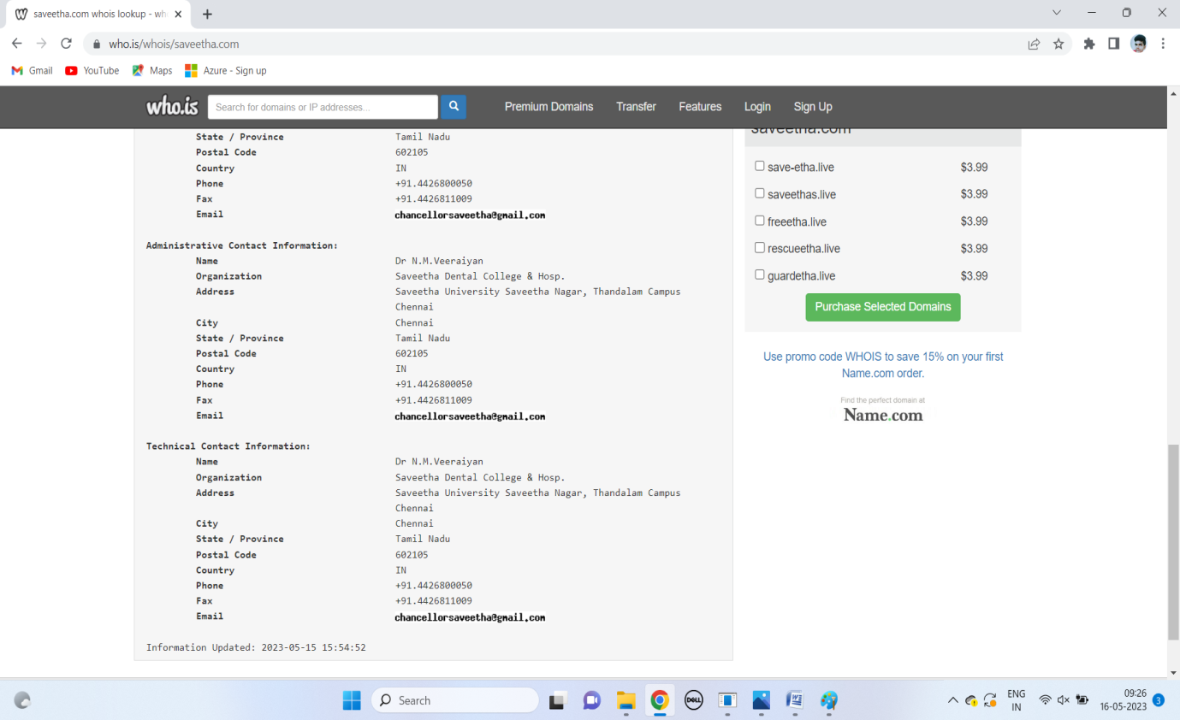

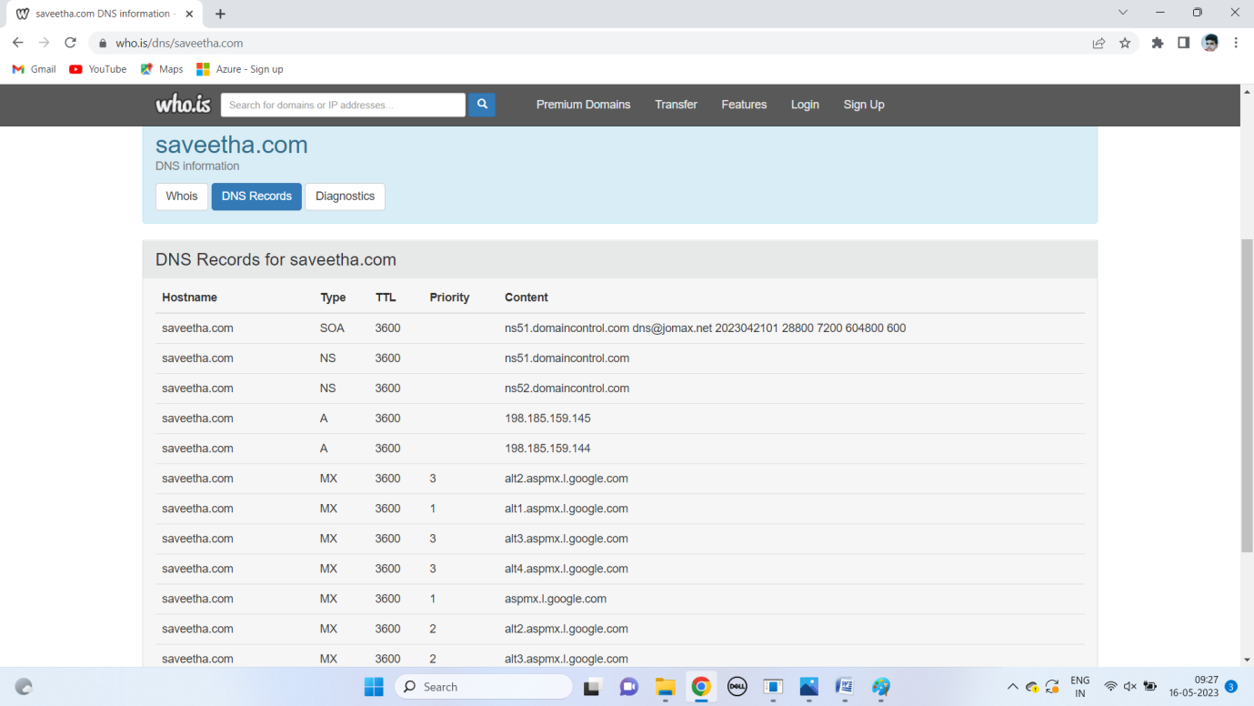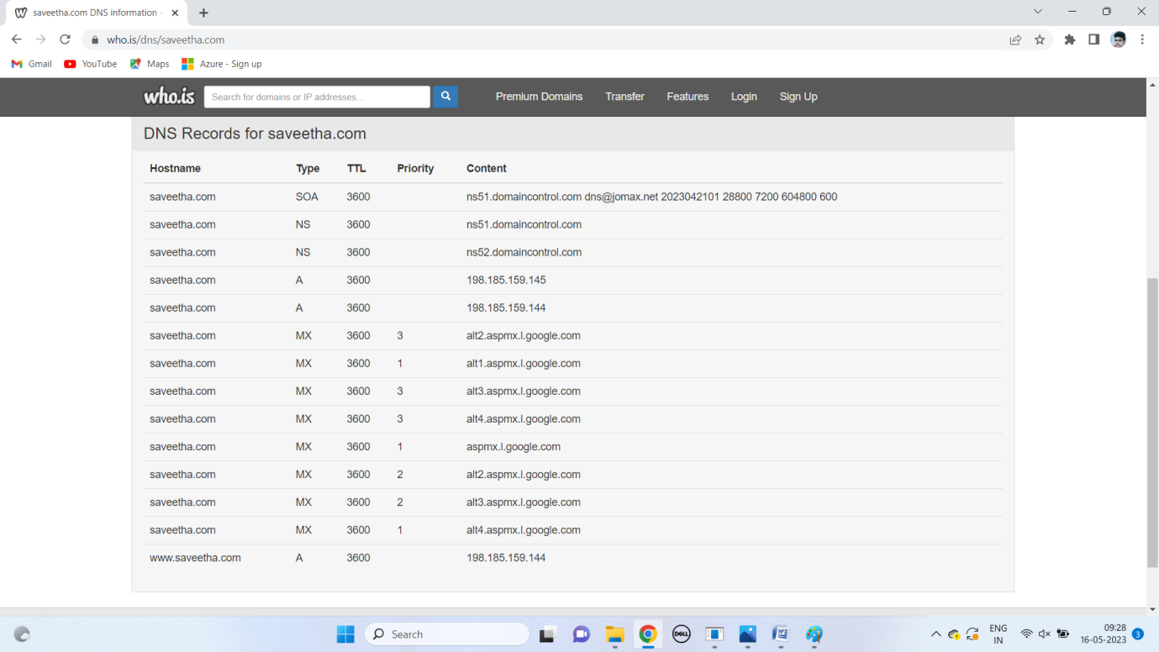

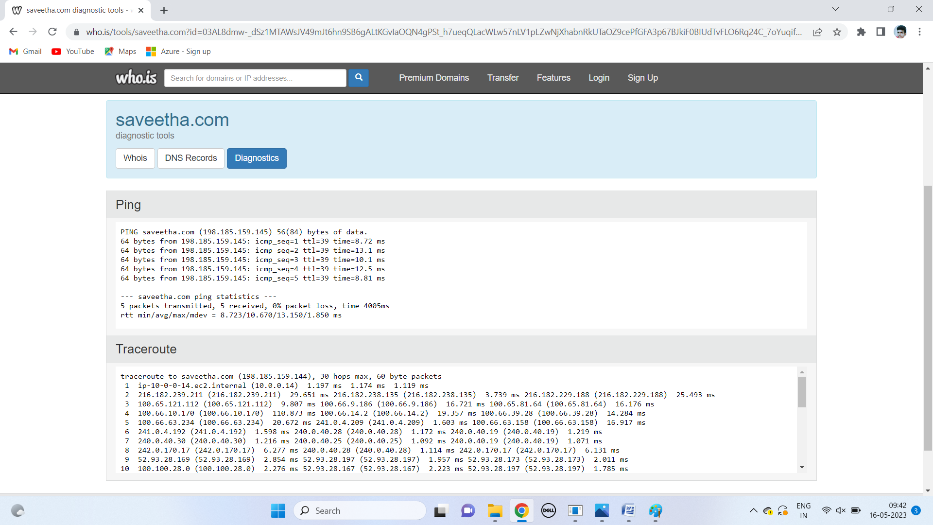

RESULT:

Finding out the Whois, DNS Records and Diagonstics for particular website by using Whois search is successfully done.